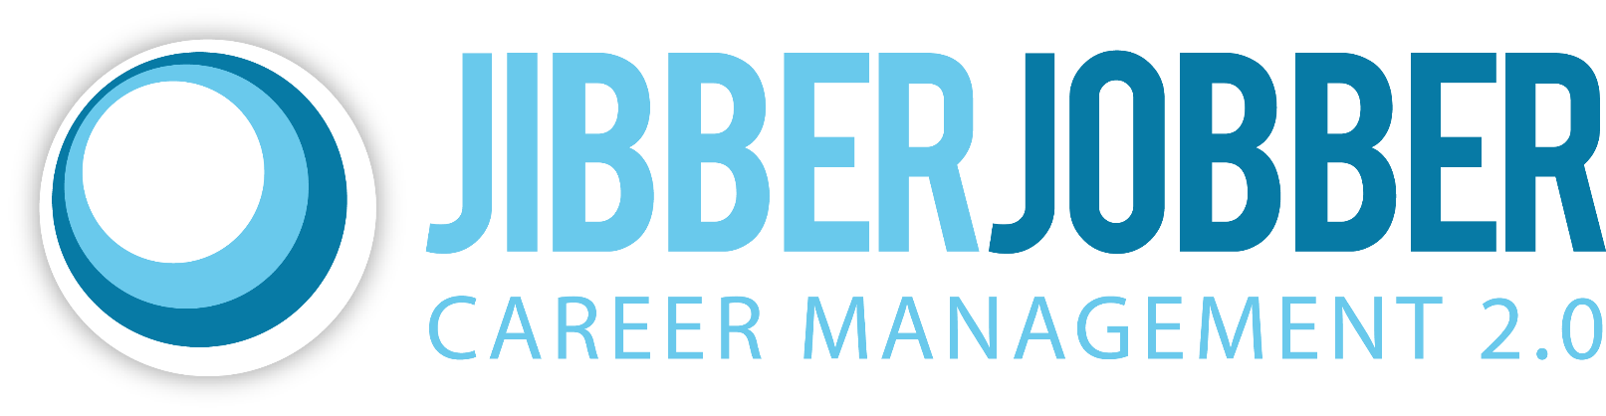

**Do you feel out of control?**

**Do you ask yourself:**

How do I keep track of all this stuff?

What do I need to do this week?

If you answer yes, you need JibberJobber!

**Who is JibberJobber for?**

* Every active job seeker
* Entrepreneur
* Happily employed
* Anyone who is career-oriented

**Two special bonuses**

30 day pass to Pluralsight library (Jason Alba courses qualify you for premium upgrades)

Free one year upgrade for veterans and military spouses.

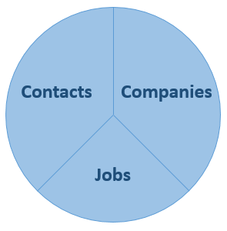

**Organize, manage, and track:**

**Get your free account here: JibberJobber.com**

**Freemium means free for life with an optional upgrade (just like LinkedIn)**

**JibberJobber is** a web and mobile app to help you manage and organize your job search.

**JibberJobber is** a follow-up tool to help you nurture personal and professional relationships.